**Introduction:**

1. What is your business? (So we are all on the same page)
   1. Local Concierge Service
2. What is the problem you are proposing to solve with this website? (So we can focus on the one particular aspect of that business that this website is intended to serve)
   1. Whatever problem you have, I will solve.

**Strategy:**

1. Who are the users of this website? (The business owner? A customer off the street? More than one kind of user? Etc.)
   1. Users of this service could be anyone from a business owner that needs his car washed and detailed, to a random person off the street that doesn’t have time to get groceries.
2. What are the needs of your users in general? Support your answer with research. (Cite your research)
   1. Based on the rise of food delivery services (instaCart, DoorDash, etc.) (<https://www.forbes.com/sites/andriacheng/2018/06/26/millennials-are-ordering-food-for-delivery-more-but-are-they-killing-the-kitchen-too/#4bcc51af393e>) and many other ordering services, I can assume the main needs of my users would be food delivery. But I do not know of any other service that offers other services along with delivery.
3. What are the objectives of your website within the context of your business as a whole? Defend your answer by describing how these are realistic objectives for the business and problem you are proposing and that meeting these objectives is appropriate to topics covered in the course and the time left in the course.
   1. The main objective of my website is to be an intuitive landing page that anyone can use to request my services. Because I understand that my users are trying to save time, I want my site to take 30 seconds to fill out.

**Scope:**

1. What content (information, pictures, etc.) must your website provide the user?
   1. Because of how simple and intuitive I want my site to be, the only content that the user needs to see is the options of services that I offer, and text boxes that the user fills out. (Name, phoneNumber, and the Service they want)
2. What functions (actions the user performs through this software) must your website provide the user?
   1. I need to be able to create receipts for the users (not done by user)
   2. Take in user information, (name, phone, service)
3. For each piece of content and function you list, clearly describe (1) who exactly benefits from this item and (2) the goal that this item helps them accomplish. If it is hard to relate an item to a user need or business objective from the previous step, it may be a sign that the item is not actually necessary.
   1. Receipts
      1. Users benefit from this because they can see the fiscal breakdown of there charges. If a user requests groceries, I can charge them for the groceries, a 5% tax for me, and a $15 charge.
   2. User Information
      1. I benefit from this information. When I call the user to get more details on there order, I can know how to address them and am able to give an accurate quote.
4. Rank the content and function items by priority. (Which items are absolutely necessary for the bare minimum, first release of this software, and which wouldn’t be needed until further down the road?)
   1. Gathering user information is definitely necessary, along with creating receipts. Both should be functional before the release of the product.

**Structure:**

1. List the ways your website would use real life metaphors. For example, your “cart” in Amazon is called a “cart” out of a metaphor to retail stores.
   1. Instead of saying car detailing, I could say car cleaning?
   2. Instead of saying grocery shopping, I could just say shopping?
   3. I don't like these...
2. For each function, what are the errors that might occur due to a fault of the user, such as by inputting bad data?
   1. User information
      1. The worst thing would be the user giving me an incorrect phone number.
      2. Another issue with my design is the lack of authentication. There’s nothing stopping a bot or malicious person filling out thousands of customer orders, and just spamming my website. Maybe before submitting data, you have to fill out a Google Captcha?
3. For each kind of error, describe how you might (1) make the error impossible or really difficult to happen, (2) help the user notice potential errors so they can fix them before it is too late, and/or (3) help the user recover from an error after it has occurred.
   1. Incorrect information
      1. Maybe I could also take in a users email address along with other information. Also there could be a screen before submit where the user gets to look back over there information.
   2. Spamming
      1. This could be solved with a Google Captcha.
4. Which of these would your website's “Navigation Scheme” resemble the most: a hierarchy like navigating folders; selecting many search options like the size, color, and fabric type when buying shirts online; organic like Wikipedia, where any page is able to connect to any other page; or sequential like a survey or a newsfeed that asks/shows you one question/item at a time.
   1. Sequential. There is no menu, or linking to another pages. There is the “main” page and a second “information confirmation page”

**Skeleton:**

1. Draw a few “wireframes” for your website and describe the functional behavior of each. (Or show a few screenshots of your rough idea for the website)
   1. 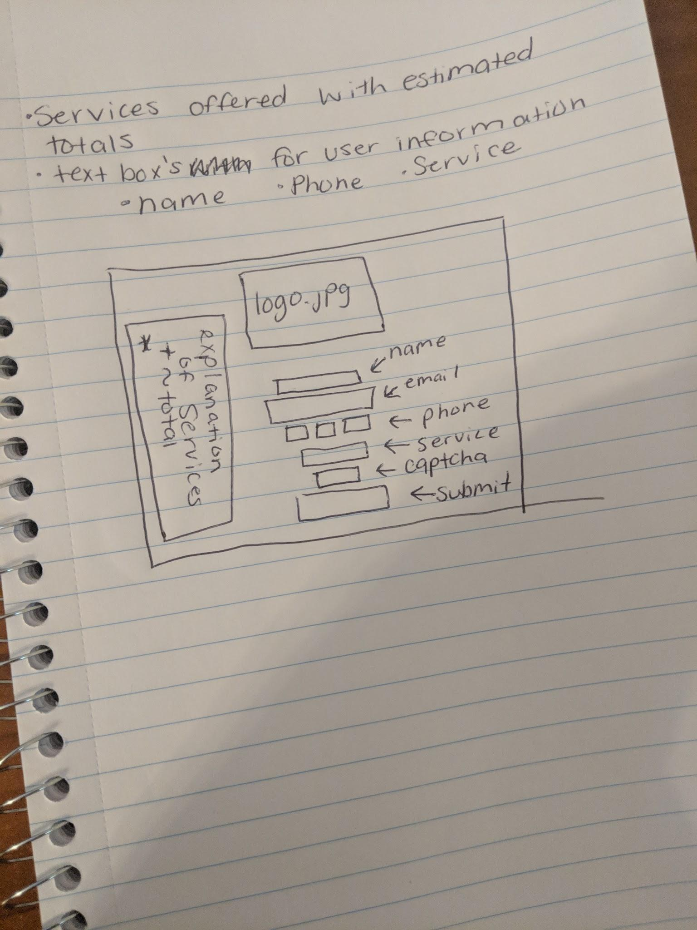
2. Discuss, based on your wireframes, the “building blocks” that will make up your website: check boxes, drop downs, buttons, images, scrollbars, etc. (How does each kind of building block help lead to your overall goal?)
   1. The main building blocks that will make up the site are text box’s (name, email, phone), a google captcha, and a dropdown menu with the services that I offer.
3. Discuss how your website might help the user identify where they are in navigating the website and quickly traverse the website as a whole. For example, File Explorer has quick links on the left that take you to frequently visited places in the hierarchy of the website.
   1. Because of the simplicity of the site, there is no room for the user to get lost!
4. Discuss how the layout of the website presents related content informatively. For example, “Name, Job title, Organization, Street address, City, State, Zip code, Telephone number, and E-mail address” could be organized into “Personal Information, Address Information, and Other Information” categories.
   1. The users personal information (name email phone) are all right above each other?

**Surface:**

1. How would your website connect to the human user through Smell (if possible)?
   1. It wont
2. Same, but for Taste? (For example, the Nintendo Switch has very bad tasting game cartridges to tell babies and pets that it is not okay to eat them)
   1. I’ll make the website background a chocolate bar so the user will try and lick there screen.
3. Same, but for Touch? Since this is likely the primary means of interaction, spend time discussing how your website uses tools like keyboards, mice, and touch screens for user input, and the specific disabilities that might prevent them from interacting in these ways.
   1. The drop-down menu and submit button are the only elements that can be ‘touched’? Also the phone number field will automatically move to the next field when entering their number.
4. Same, but for Hearing? Would your website make sounds to notify users? Does it use voice input?
   1. No, and no
5. Same, but for Vision? How would your website use color, size, space, repetition, and arrangement to denote meaning?
   1. I want to use a black and white scheme to try and emphasize important information. Spacing between elements will be a set static distance. Also the repetition of the input fields is there.

**Testing Plan:**

1. Clearly list all features that should be included in the MVP (minimally viable product, or initial prototype) version of your website. (What you've been brainstorming above is the complete version of the website, which we could never hope to complete in half a semester. Instead, we'll focus on creating an MVP with the goal of getting a prototype as quickly as possible in front of an audience for early feedback.)
   1. All the MVP would need is to take the users input, after being confirmed, and notify me via email.
2. Give the rough list of features to be included in Future Work. (This is the list of features you are choosing not to code for our class; these are mostly just the low priority tasks you listed above.)
   1. Creating a receipt
3. Clearly lay out your plan for “user testing” based on the MVP, what questions you would need user feedback to be able to answer, and how the answers to these questions might change the list of Future Work features. (If you could get a bunch of people in a room and watch them use your website, what sort of behaviors would you be looking for? What sort of questions would you ask them?)
   1. What other services would the users like to see?
   2. Do prices seem competitive?
   3. How long does it take the users to fill out the form?

One issue I was having after uploading to github, was the relative links to my images. Running on my local maching, all the images loaded perfectly, but once I uploaded it to github, everything was 404ing and not loading. I had to go back into the file after uploading, and change the hrefs from just /images/image.jpg to /concierge/images/image.jpg.